Algebra 1: Unit 8, Lesson 9

- A quadratic equation in standard form is shown.
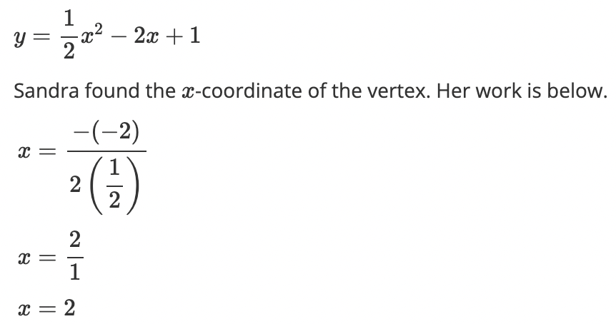
The $x$-coordinate of the vertex is $2$. What is the $y$-coordinate of the vertex?
$$-1$$

- A quadratic equation is shown.
$$y=2{(x+6)}^{2}-9$$

The equation is in vertex form. What is the vertex?
$$(-6, -9)$$

- A photographer was attempting to get the best angle of a building from a helicopter. The height of the helicopter over time is represented by the equation,
$H(x)=-1{(x-40)}^{2}+1000$, where $x$is the time (in minutes) and $H$ is the height of the helicopter (in feet).
Complete the table.
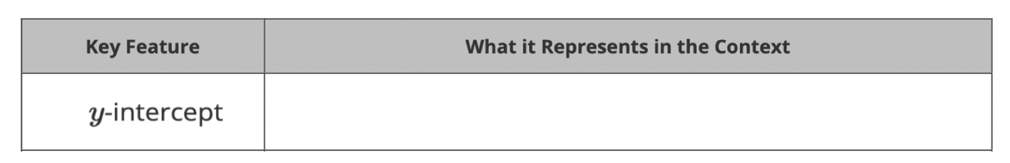

The height of the helicopter when it first takes off.

